**My SQL**

**WINDOW FUNCTIONS**

* create database new;
* use new;

1. select new_id,new_cat,Sum(new_id) Over (partition by new_cat) As "Total" from newid;

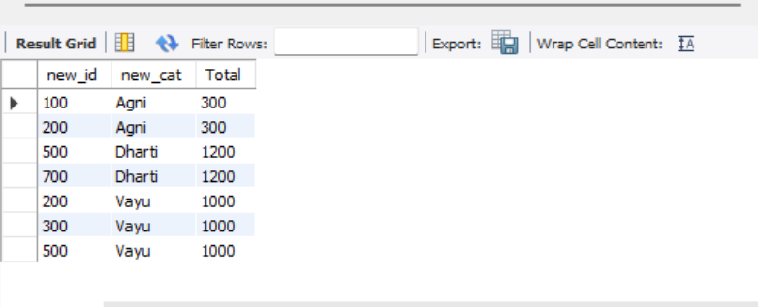

1. select new_id,new_cat,Sum(new_id) Over (partition by new_cat order by new_id) As "Total" from newid;

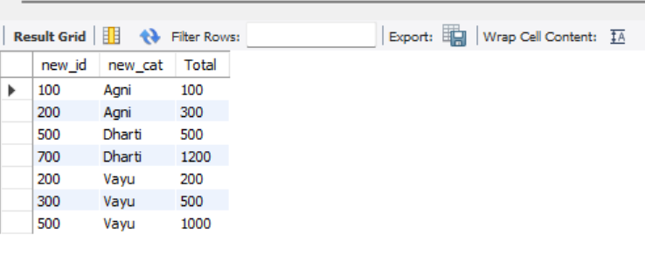

1. select new_id,new_cat,

sum(new_id) OVER (PARTITION BY new_cat ORDER BY new_id) AS "TOTAL",

AVG (new_id) OVER (PARTITION BY new_cat ORDER BY new_id) AS "Average" ,

count(new_id) OVER (PARTITION BY new_cat ORDER BY new_id) AS "COUNT",

max(new_id) OVER (PARTITION BY new_cat ORDER BY new_id) AS "MAX",

min(new_id) OVER (PARTITION BY new_cat ORDER BY new_id) AS "MIN"

from newid;

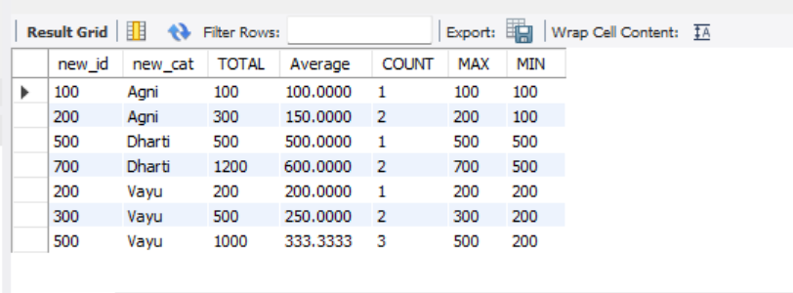

1. SELECT new_id,new_cat,

sum(new_id)over(order by new_id rows between unbounded preceding and unbounded following)

as "Total" from newid;

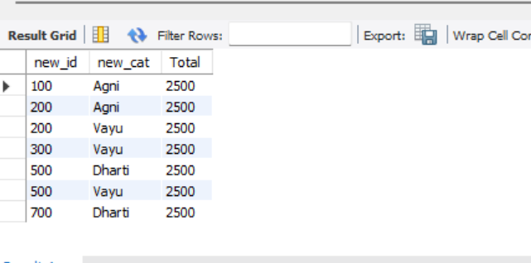

1. select new_id, row_number() over(order by new_id)

as "Row number",

rank() over(order by new_id ) as "Rank",

dense_rank() over(order by new_id) as "Dense_rank",

percent_rank() over(order by new_id) as "Percent_rank"

from newid;

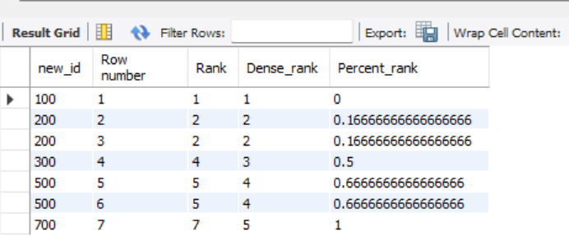

1. **Calculate the running total of sales amount**

SELECT salesid,saledate,amount,SUM(amount) OVER (ORDER BY saledate) AS "RunningTotalSales"

FROM customer;

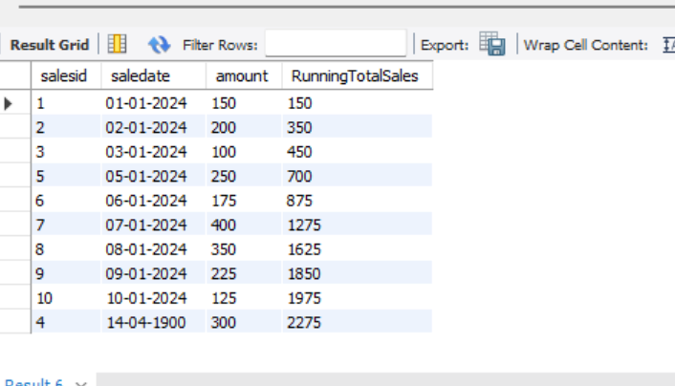

1. **Rank the sales by amount for each customer.**

SELECT salesid, saledate,customerid,amount,

rank() over(partition by customerid order by amount DESc)

AS "Rank BY Amount"

FROM customer;

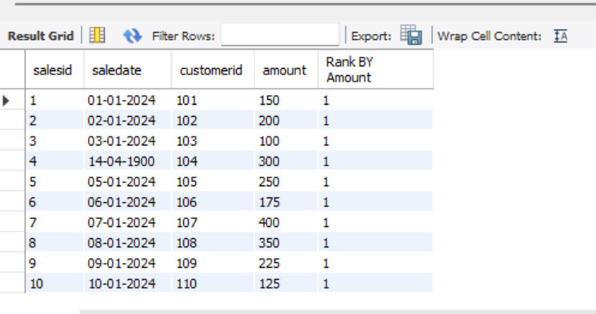

1. **Calculate avg sales amount over the last 3 sales**.

Select

salesid,saledate,

amount,

avg(amount) over(order by saledate Rows between 2 preceding and current row)

As "AvgLast3sales"

FROM customer;

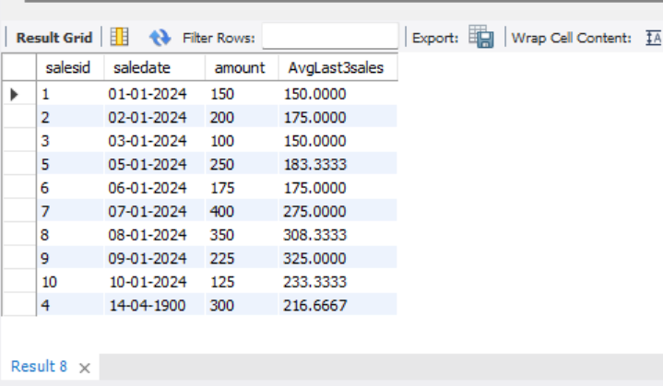

1. **Calculate the cumulative distribution sales amount.**

SELECT

salesid,

saledate,

amount,

CUME_DIST() OVER (ORDER BY Amount) AS CumulativeDistribution

FROM customer;

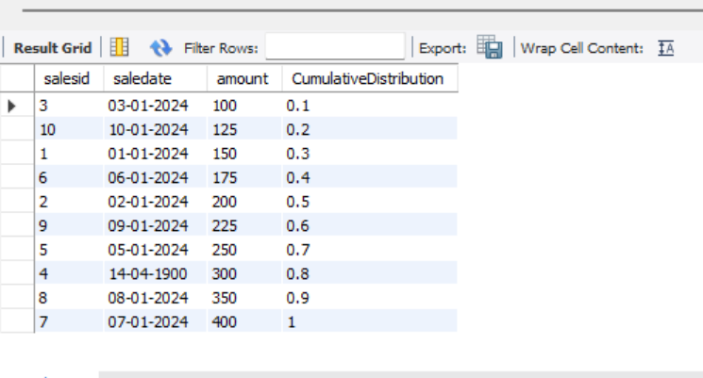

1. **Calculate the lead sales amount for the next sale**.

SELECT

salesid,

saledate,

amount,

LEAD(amount,1) OVER (ORDER BY saledate) AS SALESAMOUNT

FROM customer;

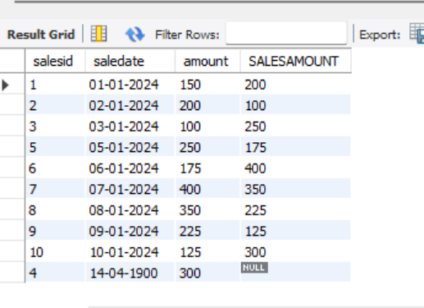

SELECT

salesid,

saledate,

amount,

Lag(amount,1) OVER (ORDER BY saledate) AS SALESAMOUNT

FROM customer;

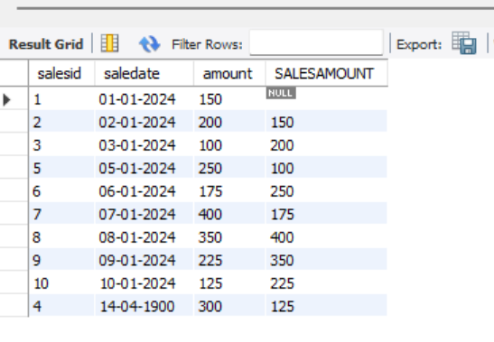

1. Find the first sale amount fir each customer.

select salesid,

saledate,

customerid,

amount,

first_value(amount) over (partition by customerid order by saledate)

as "FirstSaleAmount"

from customer;

